Telecom Customer Churn Prediction Using IBM SPSS Modeler (CHAID Decision Tree)

Objectives
The main objectives of this project are:
- To build a predictive model that classifies telecom customers into churn and non-churn using IBM SPSS Modeler.
- To identify the most important factors influencing churn using a CHAID decision tree.
- To segment customers into groups based on their churn probability and support data-driven retention strategies.

Dataset Description
The data used in this project is a telecom churn dataset stored in an Excel file and imported into IBM SPSS Modeler. Typical fields in such datasets include customer demographics (gender, age, marital status), account information (tenure, contract type, payment method, billing type), service usage (voice plan, data plan, international plan, roaming, number of calls, total minutes, total data usage), billing and revenue features (monthly charges, total charges, unpaid amounts, number of complaints), and a target variable CHURN (Yes/No) indicating whether the customer left the company during the observation period.
In the actual implementation, the exact variable names and definitions are taken from the Excel file used in IBM SPSS Modeler.

. Tools and Techniques
Software: IBM SPSS Modeler.
Modeling technique: CHAID (Chi-squared Automatic Interaction Detection) decision tree, a tree-based classification algorithm that splits data using chi-square tests to find statistically significant relationships between predictors and the target variable.
CHAID handles many categorical predictors effectively, provides easy-to-interpret tree structures and rules for business users, and can group categories of predictors that behave similarly with respect to churn.

SPSS Modeler Stream Design

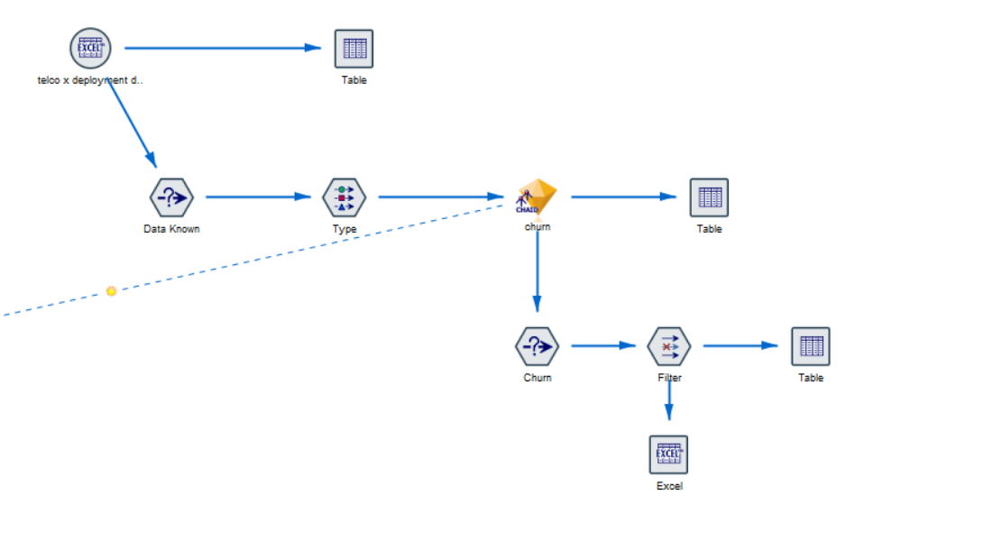
The IBM SPSS Modeler stream for this project consists of the following components:
Data Import (Excel node): Connects to the telecom churn Excel file and reads all records and fields, ensuring that numeric and string columns are correctly recognized.
Data Understanding / Data Audit (Data Known node): Checks for missing values, unique values, minimum–maximum values, and distributions of each variable, identifying variables with high missing percentages or outliers.
Data Preparation and Role Assignment (Type node): Defines the role and measurement level of each field. The CHURN field is set as the Target and Flag/Nominal, predictor variables are set as Input, and irrelevant fields such as customer ID are set as None.
Modeling (CHAID node): Builds the decision tree model using the prepared data, with parameters such as maximum tree depth, minimum cases in parent and child nodes, and significance level for splitting.
Output and Deployment (Table, Filter, Excel nodes): Displays the scored dataset and model outputs in tabular form, filters high-risk churn customers, and exports the final scored data back to Excel for business use.

Model Evaluation
The performance of the CHAID churn model is evaluated using standard classification metrics. A confusion matrix summarizes the number of correctly and incorrectly classified churners and non-churners. From this matrix, overall accuracy, sensitivity (recall for the churn class), and specificity (correct identification of non-churners) are computed.
Additional evaluation tools such as gain and lift charts or ROC curves can be used to compare the model against random selection and to understand how effectively it ranks customers by churn risk. In practice, particular attention is paid to the recall for churners because the main objective is to identify as many high-risk customers as possible for targeted retention actions.

Key Findings and Insights
The CHAID decision tree highlights several key drivers of churn. Contract type is often the most influential factor, with customers on month-to-month contracts showing much higher churn rates than those on one-year or two-year contracts. Tenure is another important driver, where new customers with low tenure exhibit higher churn than long-standing customers.
Billing-related variables such as monthly charges and total charges also play a significant role; customers paying higher charges without perceiving sufficient value tend to churn more. Service-related features (such as the presence of certain add-on services or support options) can either reduce or increase churn depending on how they are priced and communicated to customers. Specific high-risk segments can be identified by combining these factors, such as month-to-month customers with high monthly charges and short tenure.

Conclusion
In conclusion, this project demonstrates how IBM SPSS Modeler and the CHAID decision tree algorithm can be used to predict telecom customer churn and discover meaningful customer segments. By analyzing customer characteristics, contract details, and usage behavior, the model highlights high-risk segments where churn probability is much higher than the overall average.
These insights enable management to design targeted retention campaigns, optimize pricing and contract structures, and improve overall customer experience. When integrated into the company's customer relationship management processes, the churn prediction model becomes a powerful tool for reducing churn and increasing long-term customer value.

